**2nd Lt David Crow**

**ENG/20M**

**CSCE 560 Homework 4**

**Chapter 4 – Network Layer**

**Fall 18**

**Assigned: Monday, 5 Nov**

**Due: Monday, 19 Nov, 1400**

**Problem 1**. Chapter 4, R2

We noted that network layer functionality can be broadly divided into data plane functionality and control plane functionality. What are the main functions of the data plane? Of the control plane?

According to the book, the data plane provides “the per-router functions in the network layer that determine how a datagram … arriving on one of a router’s input links is forwarded to one of that router’s output links.”

Again, according to the book, the control plane provides “the network-wide logic that controls how a datagram is routed among routers along an end-to-end path from the source host to the destination host.”

In short, the data plane functions allow data to pass through *one* router along a source-destination path, and the control plane functions allow data to cross *all* intervening routers along a source-destination path.

**Problem 2**. Chapter 4, R3

We made a distinction between the forwarding function and the routing function performed in the network layer. What are the key differences between routing and forwarding?

Forwarding is the in-router action of moving a packet from an input link to an output link. It operates on a short timescale and is typically implemented in hardware.

Routing, on the other hand, is the network-wide process that determines a packet’s source-to-destination path. It operates on longer timescales and is typically implemented in software.

**Problem 3**. Chapter 4, R17

Suppose Host A sends Host B a TCP segment encapsulated in an IP datagram. When Host B receives the datagram, how does the network layer in Host B know it should pass the segment (that is, the payload of the datagram) to TCP rather than to UDP or to some other upper-layer protocol?

The Upper-Layer Protocol field in the IP datagram – which is only used when the datagram reaches its final destination – indicates to which transport-layer protocol the IP datagram should be passed. A value of 6 indicates the datagram should be passed to TCP; a value of 17 indicates the datagram should be passed to UDP.

**Problem 4**. Chapter 4, R18

What field in the IP header can be used to ensure that a packet is forwarded through no more than N routers?

The time-to-live field, which is decremented by one each time a datagram passes through a router, ensures that the datagram is dropped when the value of the field reaches zero.

**Problem 5**. Chapter 4, R21

Do routers have IP addresses? If so, how many?

Routers have one IP address for each interface. At a minimum, then, routers have two IP addresses (one for incoming traffic and one for outgoing traffic).

**Problem 6**. Chapter 4, R22

What is the 32-bit binary equivalent of the IP address 223.1.3.27?

Thus, .

**Problem 7**. Chapter 4, R24

Suppose there are three routers between a source host and a destination host. Ignoring fragmentation, an IP datagram sent from the source host to the destination host will travel over how many interfaces? How many forwarding tables will be indexed to move the datagram from the source to the destination?

This datagram will travel through eight different interfaces (one each at the source and destination hosts, and two at each of the routers between the source and host). Three forwarding tables (one at each intermediate router) will be indexed.

**Problem 8**. Chapter 4, R25

Suppose an application generates chunks of 40 bytes of data every 20 msec, and each chunk gets encapsulated in a TCP segment and then an IP datagram. What percentage of each datagram will be overhead, and what percentage will be application data?

Because TCP and IP each add 20 bytes of overhead, each datagram will consist of 80 bytes in total. This indicates that the overhead and application data each constitute 50% of the total datagram.

**Problem 9**. Chapter 4, R26

Suppose you purchase a wireless router and connect it to your cable modem. Also suppose that your ISP dynamically assigns your connected device (that is, your wireless router) one IP address. Also suppose that you have five PCs at home that use 802.11 to wirelessly connect to your wireless router. How are IP addresses assigned to the five PCs? Does the wireless router use NAT? Why or why not?

The wireless router uses DHCP to assign IP addresses to the five home PCs. Because the ISP only assigned one IP address to the router, the router uses NAT to allow the five PCs to fully communicate with the Internet as a whole.

**Problem 10**. Chapter 4, R32

How does generalized forwarding differ from destination-based forwarding?

Destination-based forwarding (the more traditional method) forwards packets solely using the IP address of the packet’s destination. Generalized forwarding, on the other hand, can use any number of header field values in combination with the destination IP address. For example, a router might consider network congestion on certain output ports when employing generalized forwarding.

**Problem 11**. Chapter 4, P5

Consider a datagram network using 32-bit host addresses. Suppose a router has four links, numbered 0 through 3, and packets are to be forwarded to the link interfaces as follows:

Destination Address Range Link Interface

11100000 00000000 00000000 00000000

through 0

11100000 00111111 11111111 11111111

11100000 01000000 00000000 00000000

through 1

11100000 01000000 11111111 11111111

11100000 01000001 00000000 00000000

through 2

11100001 01111111 11111111 11111111

Otherwise 3

a. Provide a forwarding table that has four entries, uses longest-prefix matching, and forwards packets to the correct link interfaces. "Otherwise" does not count as one of the four entries. In other words, you should have four entries with prefixes in your table in addition to "Otherwise" for a total of five rows/entries.

|  |  |  |
| --- | --- | --- |
| **Row** | **Prefix** | **Link Interface** |
| 1 | 11100000 00 | 0 |
| 2 | 11100000 01000000 | 1 |
| 3 | 1110000 | 2 |
| 4 | 11100001 1 | 3 |
| 5 | Otherwise | 3 |

b. Describe how your forwarding table determines the appropriate link interface for datagrams with the following destination addresses. Be sure to actually list the interface used for each datagram.

The forwarding table selects the longest prefix it can match to each destination address. It then sends the datagram to the interface associated with that prefix.

|  |  |  |
| --- | --- | --- |
| **Destination Address** | **Matched Row** | **Link Interface** |
| 11001000 10010001 01010001 01010101 | 5 | 3 |
| 11100001 01000000 11000011 00111100 | 3 | 2 |
| 11100001 10000000 00010001 01110111 | 4 | 3 |
| 11100000 01000000 00010001 01110111 | 2 | 1 |
| 11100000 00010001 01010001 01010101 | 1 | 0 |
| 223.0.16.1 | 5 | 3 |
| 224.253.1.1 | 3 | 2 |

**Problem 12**. Chapter 4, P6

Consider a datagram network using 8-bit host addresses (e.g., 10101111); we are not using 32-bit IP addresses. Suppose a router uses longest prefix matching and has the following forwarding table:

Prefix Match Interface

00 0

010 1

011 2

10 2

11 3

For each of the four interfaces, give the associated range of destination host addresses in binary and decimal and the total number of addresses for each interface.

|  |  |  |  |
| --- | --- | --- | --- |
| **Prefix** | **Range (Binary)** | **Range (Decimal)** | **Number of Addresses** |
| 00 | 00000000 through 00111111 | 0 through 63 | 63 – 0 + 1 = 64 |
| 010 | 01000000 through 01011111 | 64 through 95 | 95 – 64 + 1 = 32 |
| 011 | 01100000 through 01111111 | 96 through 127 | 127 – 96 + 1 = 32 |
| 10 | 10000000 through 10111111 | 128 through 191 | 191 – 128 + 1 = 64 |
| 11 | 11000000 through 11111111 | 192 through 255 | 255 – 192 + 1 = 64 |

**Problem 13**. Chapter 4, P11

Consider a subnet with prefix 128.119.40.128/26. Give an example of one IP address (of form xxx.xxx.xxx.xxx) that can be assigned to this network. Suppose an ISP owns the block of addresses of the form 128.119.40.64/26. Suppose it wants to create four subnets from this block, with each block having the same number of IP addresses. What are the prefixes (of form a.b.c.d/x) for the four subnets?

The leftmost 26 bits (that is, 10000000 01110111 00101000 10) define the subnet mask. Thus, anything in the range 10000000 01110111 00101000 10000000 to 10000000 01110111 00101000 10111111 can be assigned to this network; that is, anything in the range 128.119.40.128 to 128.119.40.191 can be assigned to this network. 128.119.40.150 is one such IP address.

The leftmost 26 bits (that is 10000000 01110111 00101000 01) define the subnet mask. Because the ISP thus has possible IP addresses, it should assign 16 addresses to each subnet. The prefixes are thus 128.119.40.64/26, 128.119.40.80/26, 128.119.40.96/26, and 128.119.40.112/26.

**Problem 14**. Chapter 5, R4

Compare and contrast link state and distance vector routing algorithms. What information is transmitted and to whom by each router?

Link state routing algorithms possess global knowledge about a given network, so they are able to compute the optimal source-to-destination path for any pair of nodes. In these algorithms, routers share information about the network’s connections; each router can then build a topology table and use Dijkstra’s algorithm to find all shortest paths.

Distance vector routing algorithms, on the other hand, do not possess global knowledge. Instead, each router sends its routing tables to its neighboring routers; the least-cost path is thus computed iteratively along the path. In other words, each router only knows the neighbor to which it should send a packet to ensure the packet follows the least-cost path to some destination; the routers don’t know the rest of the path said packet will take.

**Problem 15**.

Consider the network shown below, and assume that each node initially knows the costs to each of its neighbors. Consider the distance vector algorithm and show the distance table entries at node z. Be sure to show how ALL node entries change over time. Finally, show the forwarding table for node z after the algorithm completes.



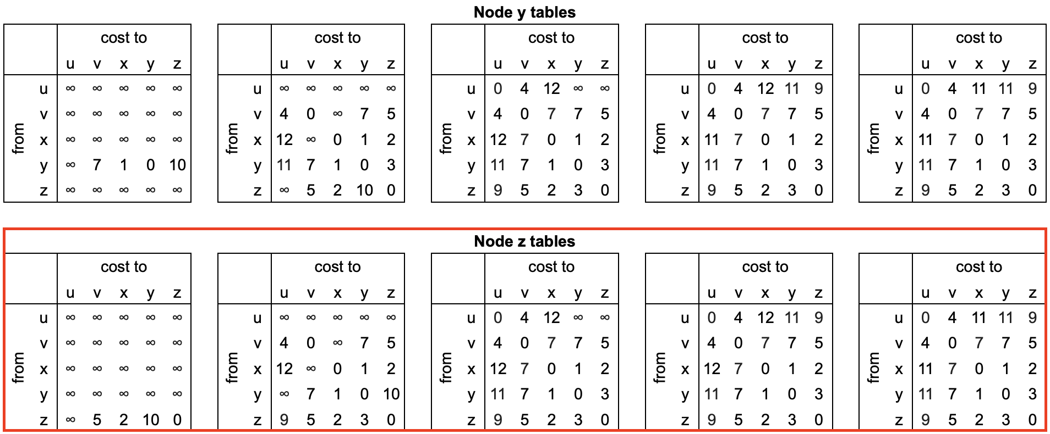

Forwarding table:

|  |  |
| --- | --- |
| Destination | Link |
| u | (z, v) |
| v | (z, v) |
| x | (z, x) |
| y | (z, x) |



**Problem 16**.

Consider the following network. With the indicated link costs, use Dijkstra's shortest-path algorithm to compute the shortest path from x to all network nodes. Show how the algorithm works by computing a table similar to Table 4.3. Use the table given below; do not change the column headings. You may not need all rows shown. Finally, show the forwarding table for node x after the algorithm completes; remember the forwarding table is derived from the table used in completing the algorithm.



|  |  |  |  |  |  |  |  |  |
| --- | --- | --- | --- | --- | --- | --- | --- | --- |
| Step | N' | D(s),p(s) | D(t),p(t) | D(u),p(u) | D(v),p(v) | D(w),p(w) | D(y),p(y) | D(z),p(z) |
| 0 | x |  |  |  | 3, x | 6, x | 6, x |  |
| 1 | xv |  | 7, v | 6, v | - | 6, x | 4, v |  |
| 2 | xvy |  | 7, v | 6, v | - | 6, x | - | 16, y |
| 3 | xvyu | 10, u | 7, v | - | - | 6, x | - | 16, y |
| 4 | xvyuw | 10, u | 7, v | - | - | - | - | 16, y |
| 5 | xvyuwt | 8, t | - | - | - | - | - | 12, t |
| 6 | xvyuwts | - | - | - | - | - | - | 12, t |
| 7 | xvyuwtsz | - | - | - | - | - | - | - |

Forwarding table:

The last column is technically not a part of the forwarding table, but it will help you determine the appropriate output link.

|  |  |  |
| --- | --- | --- |
| Destination | Link | Path from destination back to x |
| s | (x, v) | stvx |
| t | (x, v) | tvx |
| u | (x, v) | uvx |
| v | (x, v) | vx |
| w | (x, w) | wx |
| y | (x, v) | yvx |
| z | (x, v) | ztvx |

**Wireshark Lab**

Complete the lab in 04 - Wireshark_IP.pdf.

Okay.

Complete the lab in 05 - Wireshark_DHCP.pdf.

Okay.